**TITLE: AIR QUALITY MONITORING SYSTEM**

**PHASE: DEVELOPMENT PART-2**

[In this part you will continue building your project.

* Continue building the project by developing the data-sharing platform.
* Use web development technologies (e.g., HTML, CSS, JavaScript) to create a platform that displays real-time air quality data.
* Design the platform to receive and display air quality data sent by the IOT devices.]

**AIR QUALITY MONITORING**

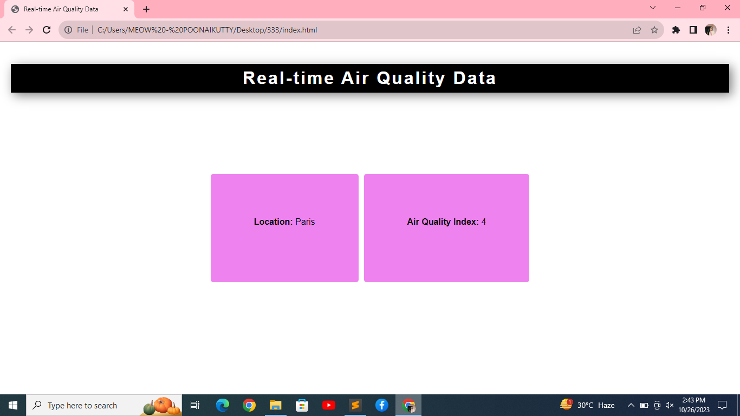

**CODE:**

**//Html Code**

<!DOCTYPE html>

<html>

<head>

<meta charset="UTF-8">

<title>Real-time Air Quality Data</title>

<link rel="stylesheet" type="text/css" href="styles.css">

<script src="script.js"></script>

</head>

<body>

<h1>Real-time Air Quality Data</h1>

<div id="dataContainer">

<div id="locationContainer"></div>

<div id="airQualityContainer"></div>

</div>

</body>

</style>

</html>

**//CSS Code**

body {

font-family: Arial, sans-serif;

margin: 0;

padding: 20px;

}

h1 {

text-align: center;

position: sticky;

top: 0;

left: 0;

z-index: 100;

padding: .5rem 5rem;

box-shadow: 5px 5px 20px rgba(0, 0, 0,.5);

background:black;

color: white;

letter-spacing: 3px;

}

#dataContainer {

margin-top: 150px;

display: flex;

justify-content: center;

height: 200px;

}

#locationContainer {

text-align: center;

padding: 80px;

margin-right: 10px;

background-color: violet;

border-radius: 5px;

}

#airQualityContainer {

text-align: center;

padding: 80px;

background-color: violet;

border-radius: 5px;

}

**//Javascript Code**

window.addEventListener('load', () => {

// Simulating real-time data

setInterval(() => {

const locationContainer = document.getElementById('locationContainer');

const airQualityContainer = document.getElementById('airQualityContainer');

// Generate random values for demonstration purposes

const city = generateRandomCity();

const airQualityIndex = generateRandomAirQualityIndex();

locationContainer.innerHTML = `<strong>Location:</strong> ${city}`;

airQualityContainer.innerHTML = `<strong>Air Quality Index:</strong> ${airQualityIndex}`;

}, 5000);

});

function generateRandomCity() {

const cities = ['New York', 'London', 'Tokyo', 'Paris', 'Sydney'];

const randomIndex = Math.floor(Math.random() * cities.length);

return cities[randomIndex];

}

function generateRandomAirQualityIndex() {

return Math.floor(Math.random() * 100);

}